Roger Webb Plays Gershwin
(MFP 50099)

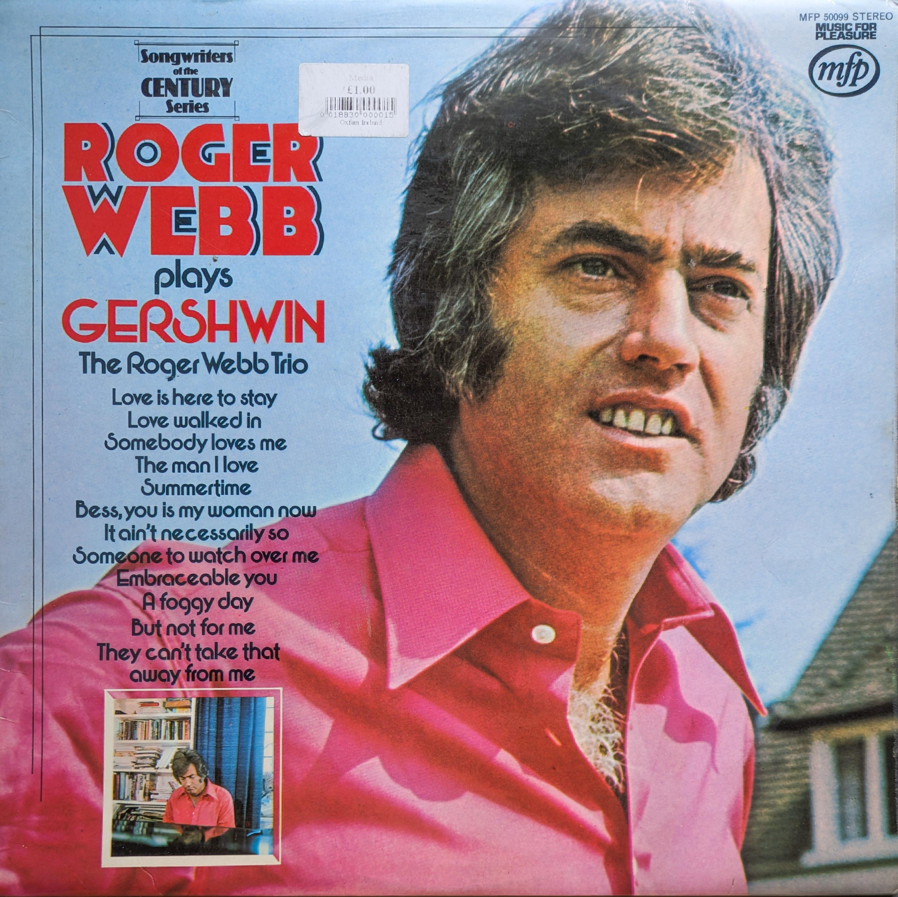
This album presents a suite of Gershwin arrangements by the Roger Webb Trio, a UK-based jazz ensemble led by the exceptionally talented pianist, composer, and arranger Roger Webb. I don’t think Roger Webb is generally well-known, his work in film and television (including the haunting score for Bartleby) is relatively hidden, although highly sought-after after by collectors. Here his arrangements are both casually inventive yet very respectful of the source material. It is, after all, a Music For Pleasure record so it is not way off piste; a pretty jazz outing and a very easy and enjoyable listen.

There is no denying the musicianship on these recordings Webb and his trio bring a polished, studio-ready precision, likely honed through their work in stock and production music. The result is a record that, while not groundbreaking, is clearly well-crafted and very enjoyable, appealing to both jazz enthusiasts and casual listeners. Webb’s self-taught improvisation is sublime; this is particularly evident on the trio’s version of It Ain’t Necessarily So, where the piano is given free rein to go a-wandering.

One caveat, however, is the album’s cover art, which is, frankly, atrocious. Its garish design and clashing fonts do a disservice to the music, but don’t let that deter you. Had it been issued with a stylish mid-century modern jazz sleeve, I suspect it would be a far more sought-after record. Instead, it deserves to be judged solely by the music.

